Website Development Process

A Case Study of Sweet Finger

Prepared by: Your Name  
Date: Your Date

# Table of Contents

1. Introduction  
2. Website Structure  
3. Design Process  
4. Content Integration  
5. Conclusion

Introduction

The "Sweet Finger" website is a visually engaging platform designed to showcase a variety of baked goods, likely specializing in cakes and desserts. With a focus on aesthetic appeal and user-friendly navigation, the site aims to attract potential customers by offering a glimpse into its offerings and values. The website employs HTML and Tailwind CSS for its design and layout, leveraging high-quality images to enhance its visual identity.

This report evaluates the current state of the website, including its structure, design, and technical implementation. Key elements such as the sitemap, HTML structure, CSS utilization, and image optimization are analyzed. Additionally, recommendations are provided to improve performance, accessibility, and overall user experience, ensuring the website meets modern web development standards and user expectations.

By addressing identified issues and implementing proposed improvements, the "Sweet Finger" website can achieve its full potential as a compelling and efficient digital presence.

**Overview**

This report evaluates the "Sweet Finger" website's structure, design, and technical implementation. The website uses HTML, Tailwind CSS, and various image resources to present a visually appealing platform likely focused on cakes or baked goods.

**1. Sitemap**

The website consists of five primary pages:

1. **Homepage (index.html)**
   * Welcomes users with branding and navigation links.
   * Highlights the purpose of the site (e.g., showcasing cakes and services).
2. **About Page (about.html)**
   * Provides information about the brand "Licking" or its mission.
   * Features background imagery and structured content.
3. **Menu Page (menu.html)**
   * Lists cakes or items in a grid layout.
   * Likely categorized for better user navigation.
4. **Contact Page (contact.html)**
   * Features a contact form with fields like name, email, and message.
   * Supports customer inquiries.
5. **Special Page (special.html)**
   * Appears incomplete, potentially intended for showcasing promotions or seasonal offers.

**2. Technical Evaluation**

**HTML Structure**

* Well-structured with semantic tags (e.g., <header>, <main>, <footer>).
* Consistent navigation bar across all pages.
* Reliance on Tailwind CSS for styling results in clean, minimal code.

**CSS Analysis**

* No custom CSS file detected.
* All styling depends on the Tailwind CSS CDN, which is efficient but limits customization and branding opportunities.

**Images**

* **Strengths**:
  + High-quality visuals enhance the website's aesthetic appeal.
  + Use of modern formats like AVIF demonstrates partial optimization efforts.
* **Weaknesses**:
  + Large file sizes (3–3.5 MB for some images) can lead to slow page load times.
  + Image formats are predominantly JPG, which are less efficient compared to WebP or AVIF.
  + Missing image alt attributes in HTML may reduce accessibility.

**Performance**

* Likely responsive design due to Tailwind's framework.
* Potential slow loading due to unoptimized assets (images).

**3. Recommendations**

**HTML and CSS**

1. **Add a Custom Stylesheet**:
   * Use a styles.css file for branding (e.g., unique fonts, color themes, hover effects).
2. **Accessibility Enhancements**:
   * Add alt attributes to all images.
   * Ensure navigation is keyboard-friendly.

**Images**

1. **Compression**:
   * Reduce image file sizes using tools like TinyPNG or ImageOptim.
   * Example: Compress images over 1 MB to under 500 KB.
2. **Modern Formats**:
   * Convert images to WebP or AVIF where feasible.
   * Retain high-quality formats for product visuals.

**Performance**

1. **Lazy Loading**:
   * Implement lazy loading for images to improve performance.
   * Example: Add loading="lazy" attribute in <img> tags.
2. **Asset Minification**:
   * Minify HTML and any custom CSS or JavaScript files to reduce file sizes.

**Special Page**

* Finalize special.html with relevant content, such as discounts or seasonal offerings.
* Include engaging visuals and call-to-action buttons.

**4. Future Development**

1. **SEO Enhancements**:
   * Include meta descriptions and keywords in all pages.
   * Add structured data (JSON-LD) for better search engine visibility.
2. **Analytics Integration**:
   * Embed Google Analytics or an alternative to track visitor behavior.
3. **Scalability**:
   * Consider a CMS (e.g., WordPress or Contentful) for easier content updates.
   * Integrate an e-commerce feature if selling cakes online is intended.

WEBSITE IMAGES

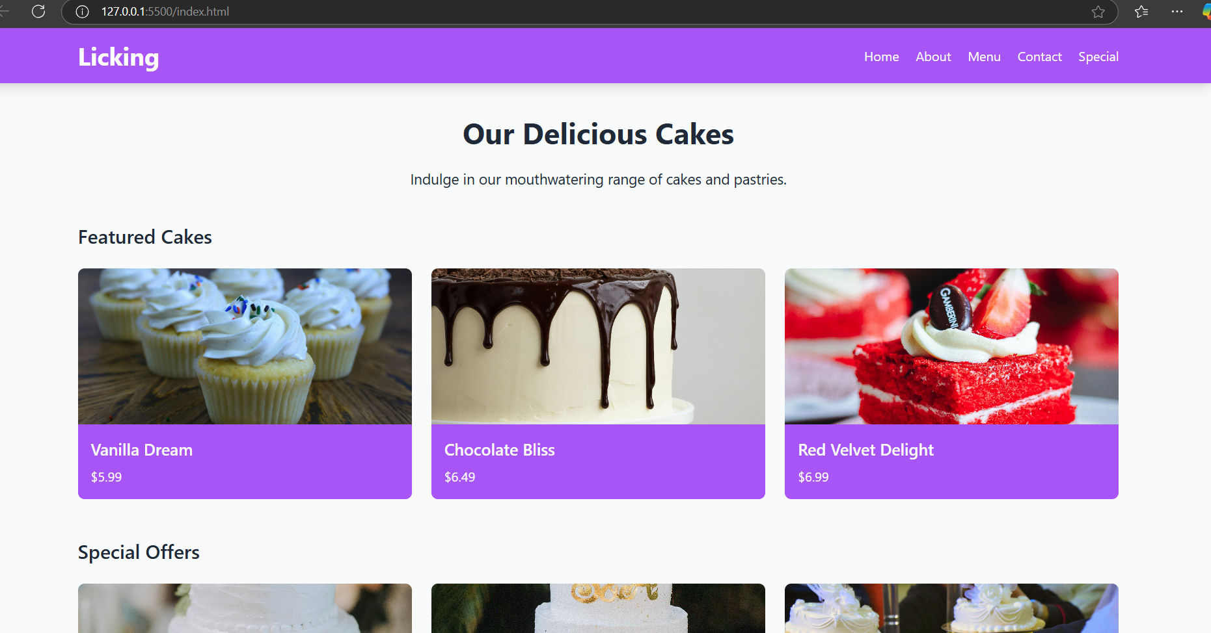

Figure 1

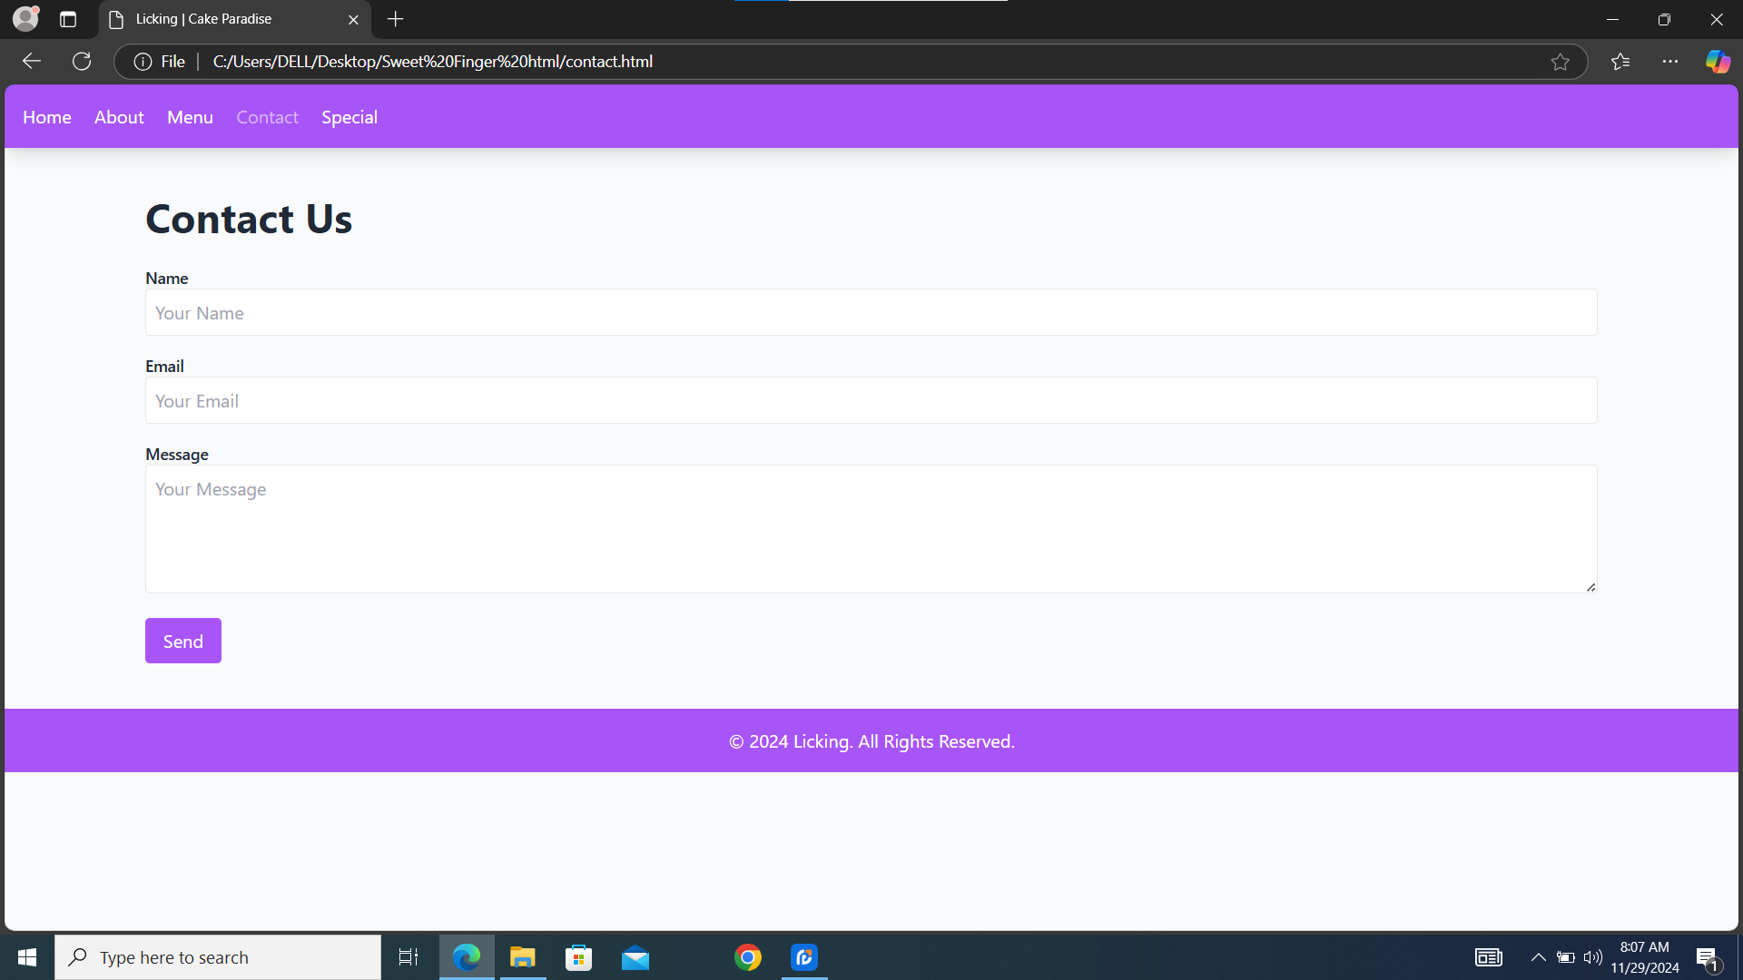

Figure 2

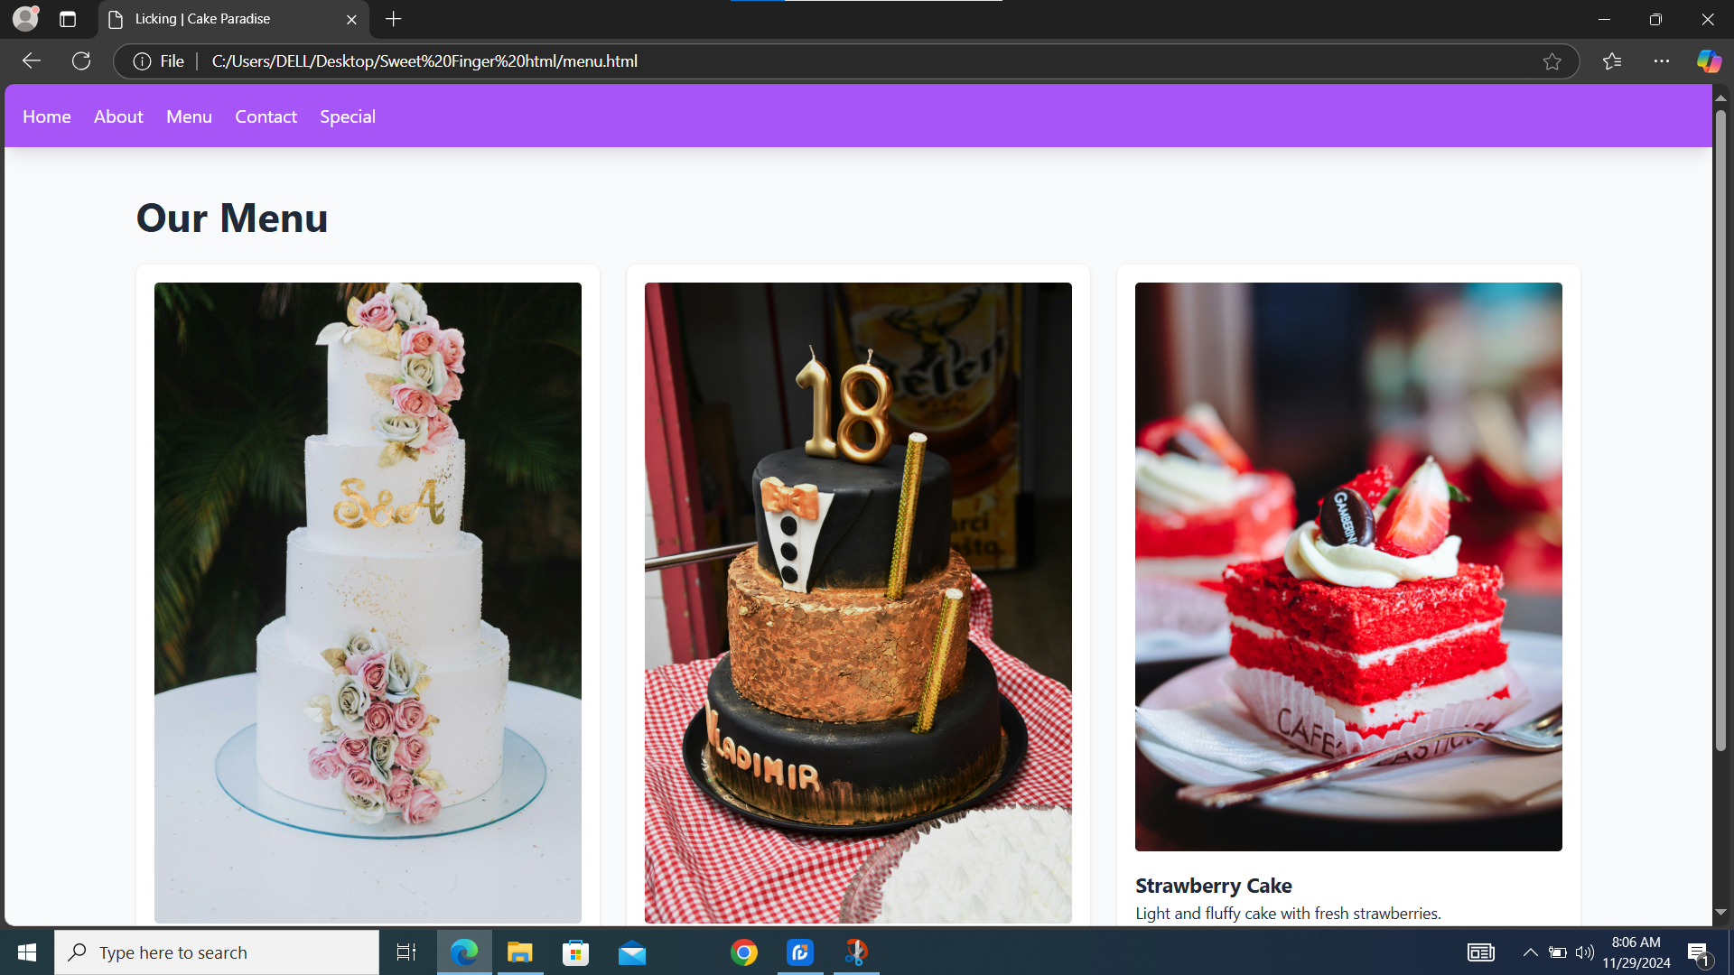

Figure 3

**Conclusion**

The "Sweet Finger" website showcases a strong foundation, with an appealing design and a clear focus on its product offerings. Its use of Tailwind CSS ensures responsiveness and a modern aesthetic, while its high-quality visuals make the site visually engaging. However, there are areas for improvement, including optimizing image file sizes, enhancing accessibility, and adding a custom stylesheet for greater branding flexibility. Completing unfinished pages, such as the "Specials" section, and implementing performance enhancements like lazy loading and SEO optimization, will further elevate the website’s functionality and user experience.

With these adjustments, the website has the potential to stand out as a professional and customer-centric digital presence. By focusing on performance, design refinement, and user engagement, "Sweet Finger" can strengthen its online identity and achieve its goals in showcasing its baked goods to a broader audience.